Primary 3 Newsletter – Term 3
Happy New Year!
Primary 3 have had a very successful first two weeks back after the Christmas break and are looking forward to a very busy term.

Literacy
We enjoyed learning our chosen poem “Up in the Morning Early” by Robert Burns as part of the whole school celebration of Robert Burns Day. All the children did a great job of reciting the poem to the rest of the class.
Core targets for literacy will continue to be reinforced across learning. The children will be encouraged to self-check for correct punctuation and consider letter formation carefully in all written tasks. Common words will be regularly revised through spelling, reading and writing tasks alongside weekly phoneme words. During group reading there will be opportunities to engage in a variety of strategies, including choral reading. Our first block of writing will be on imaginative writing with a focus on describing settings. We will also complete blocks of writing developing skills in letter writing, retelling a story and report writing.

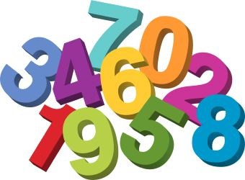
This Photo by Unknown Author is licensed under CC BY-NC-ND

Numeracy and Maths
During mental maths sessions, the children will continue to concentrate on improving the accuracy and speed of their addition and subtraction facts. The 2,3,4,5 and 10 times tables will be introduced and reinforced. We will continue to use the Big Maths characters, such as ‘Squiggleworth’ to investigate the place and value of digits in whole numbers, with numbers to 1000 being introduced and explored.
We will be learning about money this term, recognising the notes and coins, adding amounts of money together and finding change from £10. We will also be practicing our measuring skills looking at length, weight and area.

Interdisciplinary Learning
This term our first topic will be “My Scotland, My Community.” The main focus for this will be looking at the jobs that people do in our community and what they involve. “Around the World” will be the title of our topic for the second part of the term. This will focus on weather and climate, both here and around the world.

General reminders
* PE classes are on a Monday and a Friday – Mrs Begg, our P.E. specialist, requests that tights and earrings are removed for P.E.
* Library sessions are every second week on a Wednesday.
* Homework is issued weekly, literacy on a Monday and maths on a Tuesday, with both due in on a Friday.
* Reading books are studied in class twice a week. Diaries will continue to give details of reading homework
* Reading folders and diaries should be brought to school every day.
* Water bottles for use in class should be only be filled with water.
* Toys (including cuddly toys) should only be brought to school on a Friday if children wish to play with them during Golden Time.
If you need any further information please do not hesitate to contact me.
Kind regards,

Mrs J Powell

